Chilled Avocado Soup
Ingredients
- 2 very ripe avocados
- 1 garlic clove, minced
- 3 cups chicken stock
- 2 tablespoons lime juice
- 2 tablespoons sour cream
- 2 dashes Tabasco Sauce
- salt and black pepper

Directions
- Using a blender or food processor, puree the avocados and garlic.
- With the machine running, pour in the broth until it's smooth and reaches the desired consistency.
- Add the lime juice, sour cream, Tabasco and salt & pepper to taste.
- Chill at least an hour.
- To serve, you can top with a dollop of sour cream, chopped green onion, or more Tabasco.

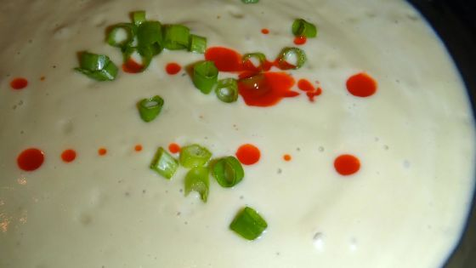

Watermelon Gazpacho

"Why not serve gazpacho at your next summer gathering? Start your hot-weather meal with this easy, intriguing variation." By Pam Anderson

Ingredients
- 2 cups 1/4-inch-diced watermelon
- 2 cups orange juice
- 2 tablespoons extra-virgin olive oil
- 1 seedless cucumber, cut into 1/4-inch dice
- 1 small yellow bell pepper, seeded and cut into 1/4-inch dice
- 1 small onion, cut into 1/4-inch dice
- 2 medium garlic cloves, minced
- 1 small jalapeno pepper, seeded and minced (optional)
- 3 tablespoons fresh lime juice
- 2 tablespoons chopped fresh parsley, basil or cilantro
- Salt and freshly ground black pepper

Directions

Process 1/2 cup of watermelon, along with the orange juice and oil, in a blender or food processor until pureed. Transfer to a medium bowl, along with remaining ingredients. Season with salt and pepper to taste. Refrigerate until ready to serve. (Can be made several hours before serving.)

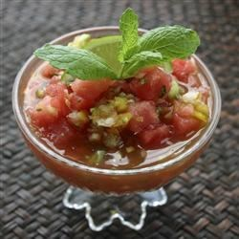

Ramon’s Fish Ceviche

Ingredients
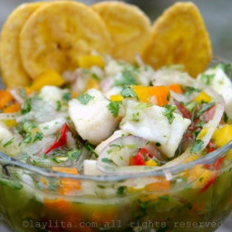
- 2 pounds of white fish fillets (corvina ; halibut, sea bass, tilapia, mahi mahi, snapper), cut into small square pieces
- 2-3 hot peppers can use Ecuadorian style aji peppers ; red chilies, or serranos, sliced
- 2-4 garlic cloves whole but gently crushed (optional)
- 2-3 small red onions ; use Ecuadorian style cebolla paiteña or replace with 4-5 large shallots, peeled and finely sliced
- 4 tomatoes, diced
- 2 bell peppers any color ; diced
- ~20 small to medium sized limes ; separated into about 10 limes to cook the fish and 10 limes for the onion and tomato marinade
- 1 bunch of cilantro ; chopped as finely as possible
- 2-3 tablespoon of oil (avocado oil ; sunflower oil, etc)
- Salt ; to taste
Bottom of Form

Directions
Place the diced raw fish in a large bowl or dish with the sliced hot peppers, garlic cloves, a tablespoon of chopped cilantro, 1-2 teaspoons of salt, and cover it with lime juice from about 10 limes, the fish should be completely covered or almost completely covered by the lime juice.
Cover the bowl with plastic wrap and refrigerate it for about 3-4 hours.
Place the sliced onions or shallots in a bowl, sprinkle them with a few teaspoons of salt and add warm water (enough to cover the onions), let rest for about 10 minutes, drain and rinse well with cold water.
Combine the rinsed onions with the diced tomatoes and diced bell peppers. Add the juice from about 5 limes and some salt. Let this mix marinate for at least 10 minutes, it can also be prepared ahead of time and refrigerated until ready to mix with the fish.
Once the fish is “cooked” in the lime juice, it should be completely white, remove the sliced hot peppers and garlic cloves. Based on your preference, and the acidity level, you can keep all the lime juice where the fish cooked in, or just some of it. You can strain the liquid to remove any pieces of hot peppers (or seeds) or garlic.
Add the marinated onion or shallot, tomato, and bell pepper mix to the fish. Add the chopped cilantro, oil, salt and additional lime juice to taste. You can serve immediately or let it rest for another 20-30 minutes before serving.

Balsamic Garlic Grilled Portobello Mushrooms

(think BBQ’d Vegetables)

Source: Sassy Southern Yankee

They are great as a side or as the main course with some other veggies.

Ingredients (all at Kroger):

4 Large Portobello Mushrooms

1/4 cup Balsamic Vinegar

1/4 Cup Olive Oil

4 Cloves Garlic, minced

1/2 Teaspoon Fresh Ground Pepper

1/2 Teaspoon Salt

Directions:

In a large plastic Ziplock bag combine the balsamic vinegar, olive oil, minced garlic, black pepper and salt. Then using a spoon lets prep the mushrooms. I always remove the “gills” from the mushrooms, but its a preference really. Using the spoon gently scoop out the “gills” and discard them; rinse the mushroom then place in the marinade.

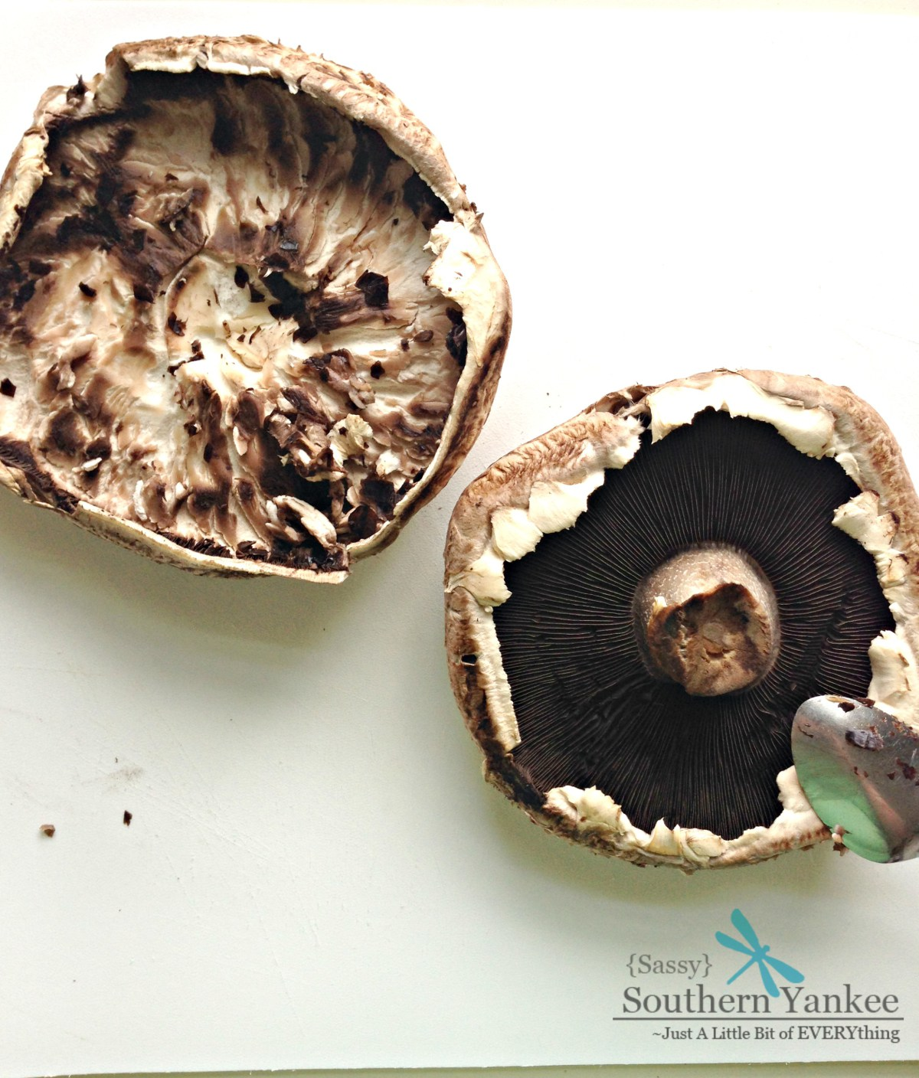
Allow the mushrooms to marinate for 30 min or overnight depending on how much time you have. I’m all about doing things the night before so my week nights are hassle free.

Preheat the BBQ or a grill pan over medium high heat; remove the mushrooms from the marinade and place them on the grill. Grill for until they are soft and tender approximately 5 minutes on each side. I prefer mine a bit charred on the edges, so I leave them a bit longer.

Tips: Prepping my lunch for tomorrow too!

Do some chicken and asparagus, too. Get a grill-ready basket!

Remove from the grill then you can slice them and serve them as a side or the main dish. These Balsamic Garlic Grilled Portobello Mushrooms remind some people, like Jenn of a great steak!

