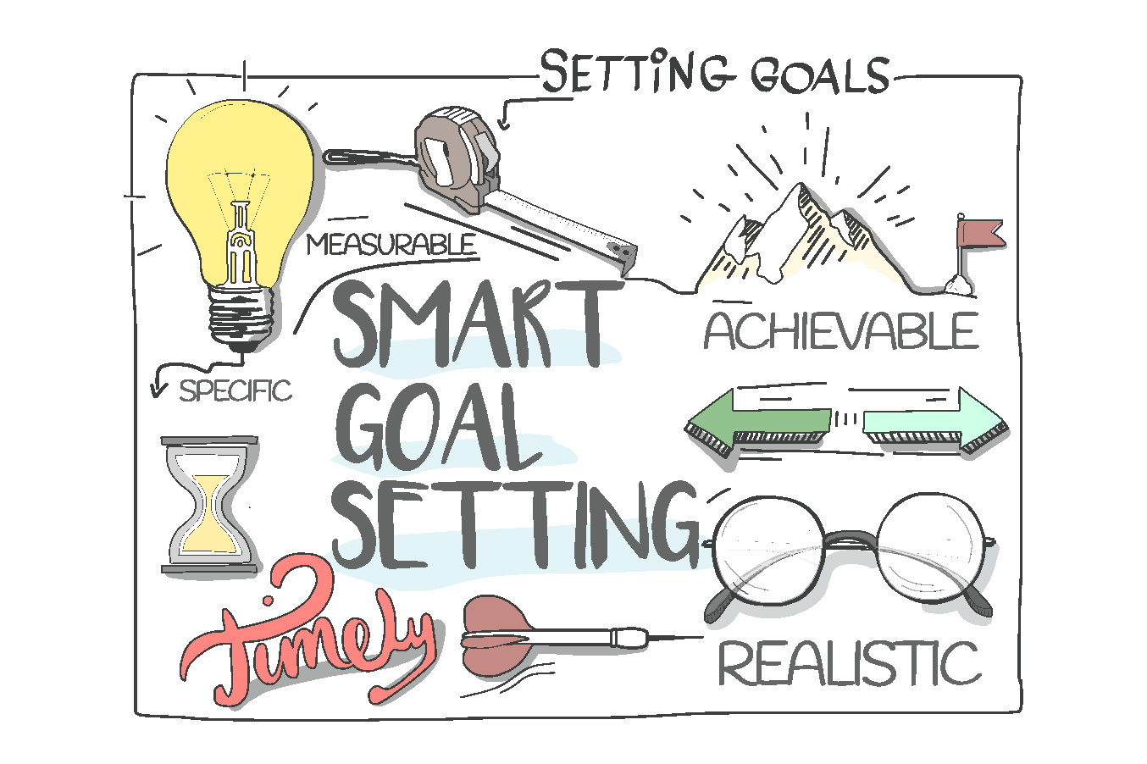
Specific:

Measurable:

Achievable:

Realistic:

Timebound:

SHOW-OFF Your Accomplishments (post pics)

